Inkpen surveys May/June 2023

Andrew Hutt

Issue 02

16th June 2023

This note is a brief summary of the work we will be undertaking in Inkpen in May/June 2023.

Figure 1 shows the 10 sites where we can carry out work. Table 1 summaries the site features and details.

The following plan of work identifies the sites we are able to work on, the order in which we are planning to do the work and the number of people who have agreed to be on site. If we finish a site early then we will move on to the next. If more people come forward to work on the sites, we will be able to do more. I am planning to extend the work into the week starting 12th June so we can finish site F1S1.

The plan of work is:

## Thursday 18th May (3 people) and 19th May (3 people)

Site F4S2 paddock: gradiometer and earth resistance survey to identify the remains of 2 19th C buildings

## Monday 22nd May (2 people), Wednesday 24th May (2 people and Friday 16th May (3 people)

Inkpen Mill site (F3S1): earth resistance survey of: a small site with terraces which may reveal evidence of earlier mill buildings

## Tuesday 30th May to 2nd June (4, 3, 2 and 4 people)

Site F5S1 possible Saxon settlements near the Folly: Gradiometer and earth resistance survey

## Monday 2nd June (2 people) and Friday 9th June (4 people)

Site F1S1

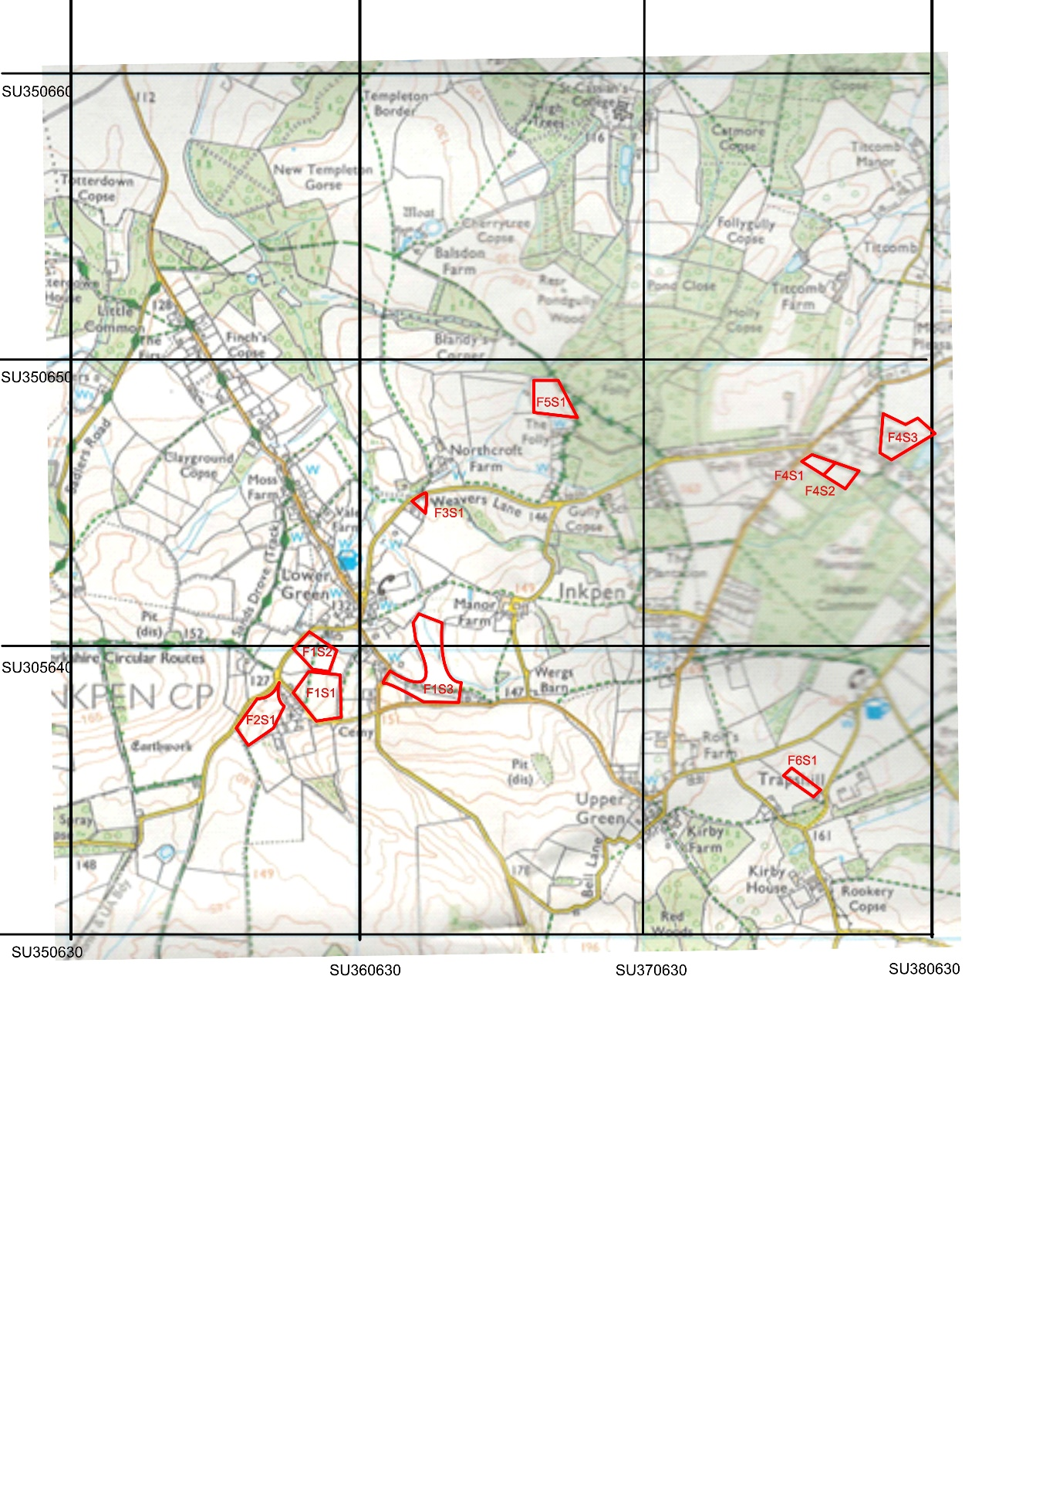



Figure 1 Inkpen sites on an OS background

|  |  |  |  |
| --- | --- | --- | --- |
| **Identifier** | **Feature details** | **Site details** | **BNGR** |
| F1S1 | Westcourt Manor | Field north east of St Michael’s Church. Field known as ‘Bancroft’ | Centroid  SU 3587 6385 |
| F1S2 | Westcourt Manor | Field to the north and west of F1S2 | Centroid SU 3584 6400 |
| F1S3 | Westcourt Manor | Land to the west of Manor Farm Cottages | Centroid  SU36286388 |
| F2S1 | Wansdyke | Field south west the Old Rickyard and south of Spray Road | Centroid SU 3564 6376 |
| F3S1 | Inkpen mill site | A collection of small garden areas to the south and west of Puddle Wharf | Centroid SU 3621 6451 |
| F4S1 | Two 19th century buildings | A paddock south of the junction of Post Office Road and Folly Lane | Centroid  SU 3758 6465 |
| F4S2 | Two 19th century buildings | A paddock south east of F4S1 with remains of 2 buildings | Centroid  SU3767 6461 |
| F4S3 | Two 19th century buildings | A field north of F4S1 and F4S2 where there may be more buildings | Centroid SU 3785 6476 |
| F5S1 | Saxon settlement near the Folly | 2 paddocks to the south of the Folly. Saxon names suggest they may be of interest | Centroid SU3 668 6487 |
| F6S1 and F6S2 | Fields near Trappshill House | Fields on the opposite side of the road to the north and north east of Trappshill House | Centroids SU 3758 6362  SU 3785 6475 |

Table 1. Features and sites of interest in Inkpen

The green shows we have completed work on this site

The orange shows sites we are planning to work on